St Daigh’s N S
Healthy Eating Policy
As part of the Social, Personal and Health Education (S.P.H.E.) Programme we encourage the children to become more aware of the need for healthy food in their lunch boxes. In addition, the Physical Education programme supports the physical development and fitness of the children. The Science curriculum also looks at the development of the body and deepens the children’s understanding of how the body grows and develops.

Aims of this policy:
- To promote the personal development and wellbeing of the child.
- To promote the health of the child and provide a foundation for healthy living in all its aspects.
- To enable the child to appreciate the importance of good nutrition for growing and developing and staying healthy.
- To enable the child to accept some personal responsibility for making wise food choices and adopting a healthy balanced diet.
Lunch is an important meal for school going children. It should provide one third of their recommended daily allowance of nutrients without being high in fat, sugar or salt. It should also provide dietary fibre (roughage).
The Healthy Lunch Guidelines

What is a healthy lunch?
A healthy lunchbox includes a helping of food from the bottom four shelves of the food pyramid
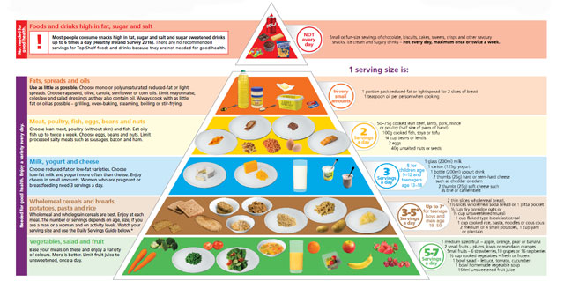

What should be in a healthy lunch?

What should not be in a healthy lunch?
- Crisps, salted nuts or popcorn
- Chocolate, sweets, lollipops or jellies
- Chewing gum
- Cake, biscuits, pastries or doughnuts
- Chocolate spread
- Fizzy drinks
- Flavoured milk
- Nuts

What drinks should be included in a healthy lunch?
- Water - Pupils are encouraged to bring a bottle of tap/still water to school. If students do not drink enough water they may become dehydrated, thirsty, tired and weak. Extra water is available in school.
- Milk (Plain)
- Diluted Sugar free squashes (1 parts squash to 10 parts water)
- Smoothies – Ideally as part on main meal

A word about Milk
- Milk is a good drink option as its tooth friendly as well as nutritious. It is an excellent source of calcium which is the main mineral present in bones and teeth. For children aged 9-18 years, 5 servings of calcium rich foods are recommended due to the importance of this mineral during this life stage.

What drinks should not be included?
- Fizzy drinks
- Sports/energy drinks
- Juice drinks
- Hot drinks (in case we spill them)
Should we make exceptions for special occasions?

- Students may bring a small treat to school on Fridays only e.g. small fun-size treat and only on Fridays
- Treats may be permitted on special occasions such as communion, confirmation or end of term
- Children’s birthday parties should not be celebrated in school.
- There are a number of children in our school, in various classes, who have serious allergies to NUTS, KIWI FRUIT and/or EGGS. With due regard to children who may be at risk of allergies and/or anaphylaxis we are declaring St Daigh’s N S a NUT FREE school.
- Please do not send nuts and/or any product containing nuts to school with your child (this includes Nutella or Nutella style spreads). Please do not send Kiwi Fruit or Egg sandwiches to school either.
- To raise awareness among pupils, staff, visitors, parents and guardians, posters conveying this message are erected at the entrance to all classrooms and at all school entrance doors
- Nutrition and Healthy Eating will be included as part of the school curriculum e.g, Food Dudes
- Teachers and staff will provide positive modelling and support attitudes to encourage healthy eating including providing non-food related rewards.
- ‘Healthy Eating Awareness Days’ will be held throughout the year as an incentive to encourage healthy eating at school and at home.
- The 'Healthy Eating Guidelines' will be reviewed every two years and the policy will be visibly displayed in the school.

Implementation
This policy has been reviewed and is effective from November 2018.
Review Timetable
This policy will be reviewed in 2 year’s time or earlier if necessary and amended as required by means of a whole school collaborative process.
Ratification & Communication
This policy was ratified by the Board of Management on 20th November 2018

_____________________________ ______________________________
Chairperson Board Of Management Principal

Date:_______________________

